User Stories:

As a unregister user, I wish to:

- Register an account

- Discover survey records

- Access the service through different devices

As a register user, I wish to:

- Login into the system

- Add and discover survey records

- Use the engagement system

- Access the service through different devices

- Export the data added by self

As an expert, I wish to:

- Add survey records without needing approval from the moderators

As a moderator, I wish to:

- Approve survey records from guest users

As an administrator, I wish to:

- Manage survey records with full permissions (i.e., add, edit, delete, export)

- Manage user account status (i.e., banning, changing roles, deleting, creating surveyor and moderator accounts)

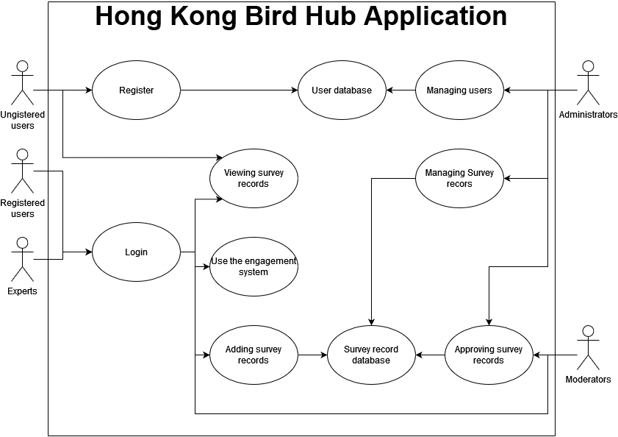

Initial sprint plan:

